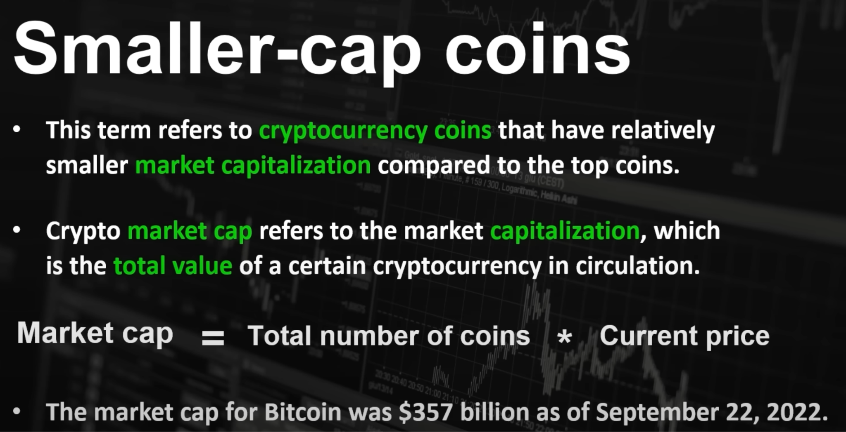

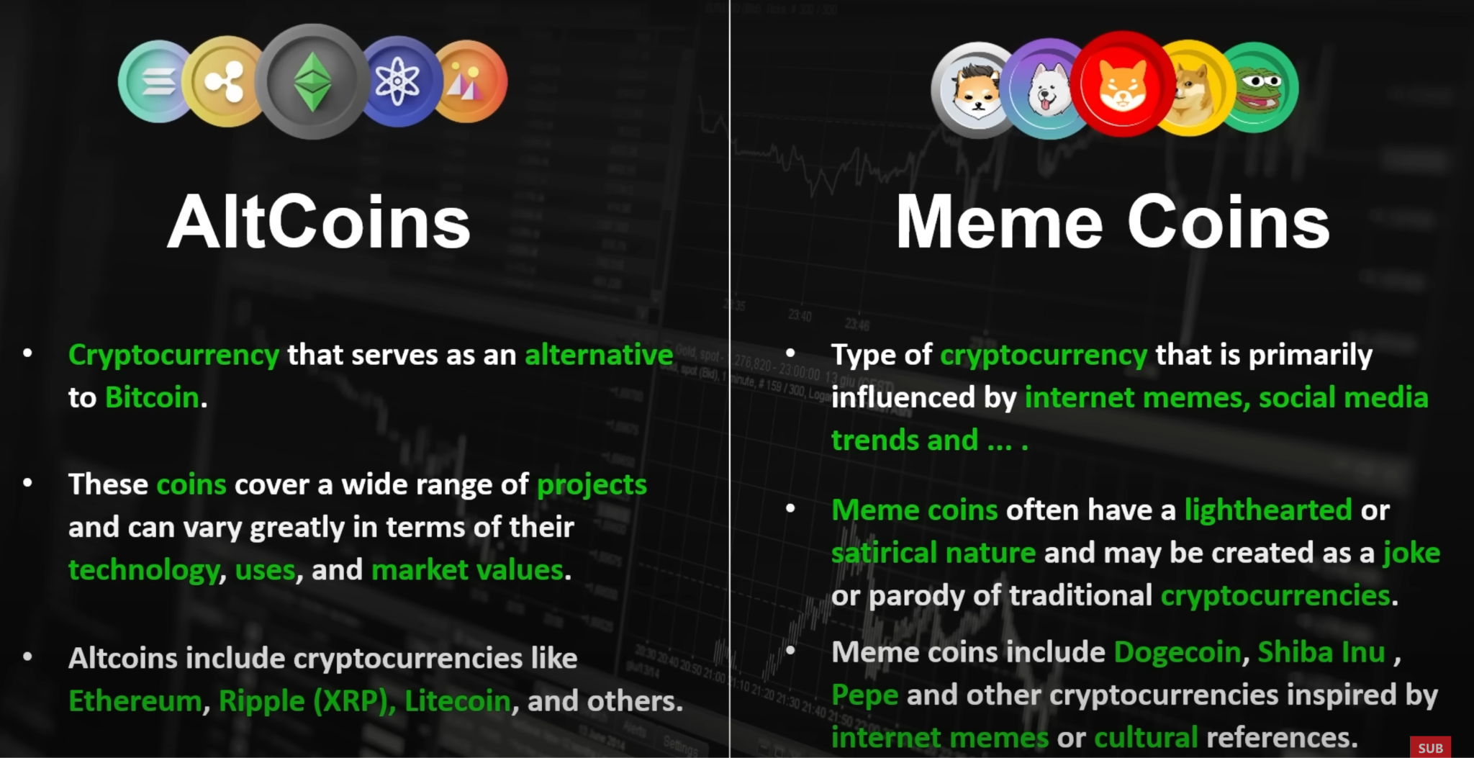

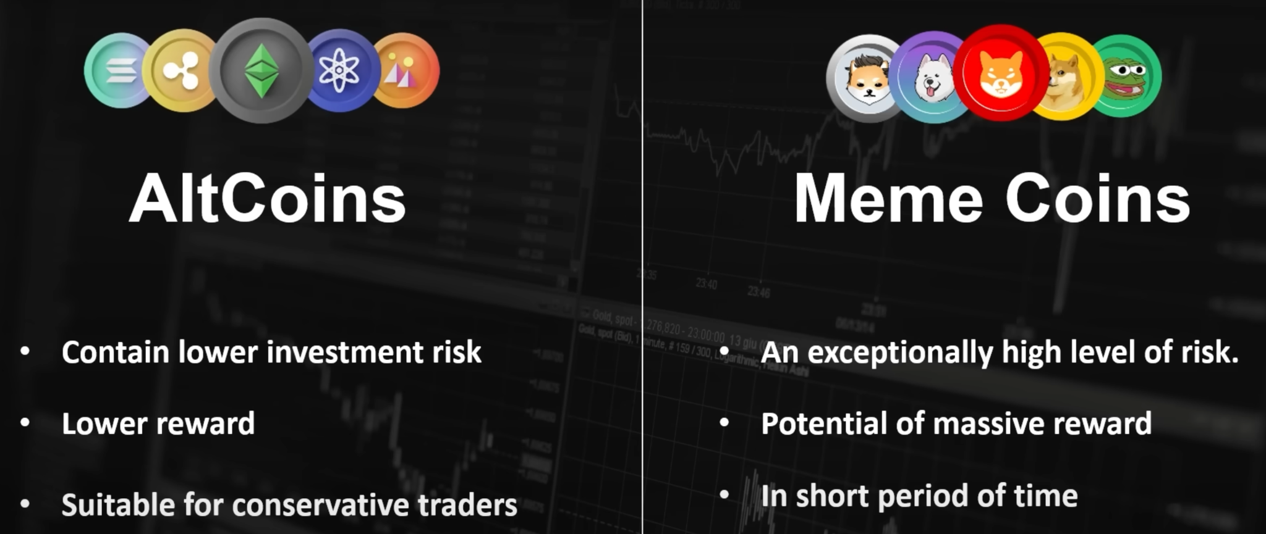

Here’s a structured guide to help you prepare detailed answers to each of these questions.

**1. General Structure, Composition, Patterns of the Crypto Market Today**

• **Structure & Composition**: The crypto market consists primarily of **spot markets**, **derivatives markets** (including futures, options, and perpetual swaps), and **decentralized finance (DeFi) platforms**. Participants range from individual retail traders to large institutions and algorithmic trading firms.

• **Patterns & Trends**: Cryptocurrencies are known for their **volatility**, with price movements influenced by macroeconomic trends, regulatory news, and market sentiment. The market has recently seen significant institutional interest, especially in **Bitcoin and Ethereum**, creating a more mature trading environment.

• **Where/How Trading Happens**: Crypto trading mainly occurs on **centralized exchanges** (e.g., Binance, Coinbase) and **decentralized exchanges** (e.g., Uniswap for DeFi). Additionally, OTC (over-the-counter) markets exist for larger transactions that can affect liquidity.

• **Market Forces Affecting Prices**: Price movements are influenced by **supply and demand**, **market sentiment**, **whale activity**, **liquidity**, and **regulatory developments**. For instance, Bitcoin’s fixed supply and halvings drive its price dynamics, while network developments (like Ethereum’s updates) can impact its valuation.

**2. Staying on Top of Crypto Markets**

• **News Aggregators & Social Media**: Platforms like **CoinDesk, The Block, and Twitter** are crucial for timely updates. Crypto is highly influenced by real-time events, so staying alert to news is key.

• **Analytics & Data Platforms**: Tools like **Glassnode, Messari, and Skew** offer on-chain analytics, market data, and derivatives information that provide deeper insights into market activity.

• **Market Metrics**: Metrics like **Bitcoin’s network hash rate, active addresses, trading volumes, and open interest in futures markets** are important indicators. Monitoring **funding rates** and **liquidation data** can signal short-term market movements.

• **Technical Analysis & Quantitative Tools**: Many traders use technical indicators like **moving averages, RSI**, and **volume data**. Automated strategies and bots can also help monitor patterns in real-time.

**3. Mechanisms of Perpetual Futures Contracts**

• **Overview of Perpetual Futures**: Perpetual futures contracts, unlike traditional futures, have no expiration date. This allows traders to hold positions indefinitely, provided they meet margin requirements.

• **Funding Rate Mechanism**: The key mechanism keeping perpetual contracts tethered to the spot price is the **funding rate**. It is a periodic fee exchanged between buyers and sellers, incentivizing positions to balance the contract price with the spot price. When the contract price is above the spot price, longs pay shorts, and vice versa.

• **Price Index & Mark Price**: Perpetual contracts track a **price index** (average of spot prices on major exchanges) to determine funding rates and mark prices. This helps mitigate manipulation and maintain fair pricing.

• **Liquidation Mechanism**: Positions are subject to liquidation if margin requirements are unmet. **Auto-deleveraging** may also apply in extreme cases, where counterparties’ positions are used to cover losses.

• **Example**: If BTC’s price is $50,000 and the perpetual contract is at $50,500, longs will pay shorts a funding fee to bring the contract price back down towards the spot price. This mechanism stabilizes the perpetual contract price.

**4. Designing a Market-Making System on Centralized Exchanges**

• **Core Structure of Market Making**: A market maker places **limit orders** on both the bid and ask sides to provide liquidity. Profit is made from the **bid-ask spread** as well as from **rebates** offered by exchanges for providing liquidity.

• **Market Neutrality**: To make the system market-neutral, it would **hedge positions on another platform** (e.g., via a perpetual swap on a different exchange) or use strategies like **statistical arbitrage**.

• **Example of Market-Neutral Approach**: The system could long on one exchange while shorting the equivalent amount on another, ensuring no net exposure to market direction.

• **Non-Neutral Strategy**: Without the market-neutral constraint, the system could take directional bets based on **momentum signals** or **predictive analytics** while still fulfilling the role of a market maker.

• **Risk Management**: Essential components include **dynamic order placement** based on volatility, **inventory management** to control exposure, and **latency optimization** to respond quickly to market changes.

• **Execution & Order Book Analysis**: For effectiveness, the system should analyze **order book depth, trade volume, and spread**. High-frequency adjustments are key, especially on exchanges with deep liquidity and fast-moving prices.

**5. Proof of Work Algorithm (Bitcoin’s Mechanism)**

• **Overview**: Proof of Work (PoW) is a consensus mechanism designed to secure the network by requiring computational effort to validate and add new blocks to the blockchain.

• **Mechanism**:

• Miners compete to solve a complex mathematical puzzle (specifically, finding a hash value below a certain threshold, called the **target**).

• The puzzle is solved by trial and error, with each attempt known as a **hash**. The goal is to create a block with a hash lower than the current target.

• Once a miner finds the correct hash, they broadcast the block to the network. Other nodes verify it and add it to the blockchain.

• **Adjusting Difficulty**: Every 2016 blocks, Bitcoin recalibrates the mining difficulty based on the average time taken to mine the last 2016 blocks. This keeps the block creation time close to 10 minutes.

• **Incentives & Security**: Miners are rewarded with newly minted Bitcoin (block reward) and transaction fees. This incentivizes participation while making it prohibitively expensive for malicious actors to attempt a 51% attack.

• **Benefits & Drawbacks**: PoW provides high security but is energy-intensive. Its robustness has made it the backbone of Bitcoin’s decentralized network.

This preparation guide should give you a solid foundation. If you’d like more specific details or examples on any topic, let me know!

# What is spot trading in crypto and how does it work?

Spot trading in crypto refers to the process of buying and selling digital currencies at their current market prices.

Spot trading is a straightforward method that allows traders to own the digital assets they acquire.

Spot trading in crypto has its advantages and disadvantages, and understanding these can help traders make informed decisions.

Understanding Spot Trading in Crypto

Spot trading in the realm of cryptocurrencies is the act of buying and selling digital assets at their current market prices. This method is often favored by new traders due to its simplicity and the fact that it allows them to own the digital assets they acquire. The aim of spot trading is to acquire digital currencies at their prevailing market prices and then sell them at higher prices to generate a return.

How Spot Trading Works in Crypto

Spot trading in crypto can be done through various platforms that allow traders to engage with digital currencies. These platforms allow traders to acquire cryptocurrencies with their local currencies or trade across several cryptocurrency pairs. To engage in spot trading, a trader needs to choose a platform, set up an account, transfer fiat currency or crypto from another wallet, and then select the cryptocurrency pair they want to trade. The trader then enters the amount they want to trade and places an order. This order is executed as soon as it matches with a corresponding order in the order book, and the trader receives their acquired crypto in their account.

Pros and Cons of Crypto Spot Trading

Like any trading method, spot trading in crypto has its advantages and disadvantages. One of the main advantages is that it allows traders to own the digital assets they acquire. This ownership can be used for various purposes, such as collateral to borrow other crypto assets or to receive yields in decentralized lending pools. Spot trading is also relatively straightforward, making it an attractive option for beginners.

On the downside, spot trading can be risky due to the volatile nature of cryptocurrency prices. Traders need to be vigilant and stay updated with market trends to make profitable trades. While spot trading allows for ownership of digital assets, it also means that traders are responsible for the security of these assets, which can be a concern given the increasing incidents of crypto theft and fraud.

Spot Trading vs. Other Trading Strategies

Spot trading differs from other trading strategies like margin or futures trading. In margin or futures trading, traders bet on the upward or downward movement of cryptocurrency prices without actually owning the cryptocurrencies. In contrast, spot trading allows traders to buy and sell the actual cryptocurrencies, providing ownership to buyers. However, it's important to note that while spot trading can be simpler, it may not offer the same potential for high returns as other more complex trading strategies.

Making the Most of Spot Trading in Crypto

To make the most of spot trading, it's crucial for traders to understand the market dynamics and stay updated with the latest trends and news in the crypto world. It's also important to have a clear trading strategy and stick to it, rather than making impulsive decisions based on short-term market fluctuations. Lastly, like any financial endeavor, it's essential to only trade with funds that one can afford to lose, as the crypto market can be highly unpredictable.

# What Is Decentralized Finance (DeFi) and How Does It Work?

By Rakesh Sharma Updated October 25, 2024

Reviewed by Amilcar Chavarria

Fact checked by Jiwon Ma

Part of the Series

A Primer on Investing in Transformative Technology

What Is Decentralized Finance (DeFi)?

Decentralized finance (DeFi) is an emerging peer-to-peer financial system that uses blockchain and cryptocurrencies to allow people, businesses, or other entities to transact directly with each other. The key principle behind DeFi is to remove third parties like banks from the financial system, thereby reducing costs and transaction times.

In the U.S., the Federal Reserve and Securities and Exchange Commission (SEC) define the rules for centralized financial institutions like banks and brokerages, which consumers rely on to access capital and financial services directly. DeFi challenges this centralized financial system by empowering individuals with peer-to-peer transactions.

Key Takeaways

Decentralized finance, or DeFi, is an emerging peer-to-peer system attempting to remove third parties and centralized institutions from financial transactions.

DeFi consists of cryptocurrencies, blockchain technology, and software that allows people to transact financially with each other.

DeFi is still in its infancy and subject to hacks and thefts because of sloppy programming and a lack of security testing before applications are launched.

Decentralization Finance

Investopedia / Joules Garcia

How Decentralized Finance (DeFi) Works

Through peer-to-peer financial networks, DeFi uses security protocols, connectivity, software, and hardware advancements. This system eliminates intermediaries like banks and other financial service companies. These companies charge businesses and customers for using their services, which are necessary in the current system because it's the only way to make it work. DeFi uses blockchain technology to reduce the need for these intermediaries.

Blockchain

A blockchain is a distributed and secured database or ledger. In a blockchain, transactions are recorded in files called blocks and verified through automated processes. If a transaction is verified, the block is closed and encrypted; another block is created with information about the previous block and information about newer transactions.

The blocks are "chained" together through the information in each proceeding block, giving it the name blockchain. Information in previous blocks cannot be changed without affecting the following blocks, so blockchains are generally very secure if their networks are large and fast enough. This concept, along with other security protocols, provides the secure nature of a blockchain.

Using applications called wallets that can send information to a blockchain, individuals hold private keys to tokens or cryptocurrencies that act like passwords. These keys give them access to virtual tokens that represent value. Ownership of the tokens is transferred by 'sending' an amount to another entity via a wallet, whose wallet, in turn, generates a different private key for them. This secures their ownership of the token, and the blockchain design prevents the transfer from being reversed.

Applications

DeFi applications are designed to communicate with a blockchain, allowing people to use their money for purchases, loans, gifts, trading, or any other way they want without a third party. These applications are programs installed on a device like a personal computer, tablet, or smartphone that make it easier to use. Without the applications, DeFi would still exist, but users would need to be comfortable and familiar with using the command line or terminal in the operating system that runs their device.

DeFi applications provide an interface that automates transactions between users by giving them financial options to choose from. For example, if you want to make a loan to someone and charge them interest, you can select the option on the interface and enter terms like interest or collateral. If you need a loan, you can search for providers, which could range from a bank to an individual who could lend you some cryptocurrency after you agree on terms.

Some applications let you enter parameters for the services you're looking for and match you with another user. Because the blockchain is a global network, you can give or receive financial services to or from anywhere in the world.

Decentralized finance does not provide full anonymity. Transactions do not include an individual's name but are traceable by anyone with the knowledge to do so. This includes governments and law enforcement, which, at times, are necessary for protecting an individual's financial interests.

Goals of Decentralized Finance

Peer-to-peer (P2P) financial transactions are one of the core premises behind DeFi, where two parties agree to exchange cryptocurrency for goods or services without a third party involved.

Using DeFi allows for:

Accessibility: Anyone with an internet connection can access a DeFi platform, and transactions occur without geographic restrictions.

Low fees and negotiable interest rates: DeFi enables any two parties to negotiate interest rates directly and lend cryptocurrency or money via DeFi networks.

Security and Transparency: Smart contracts published on a blockchain and records of completed transactions are available for anyone to review but do not reveal your identity. Blockchains are generally immutable, meaning they cannot be altered.

Autonomy: DeFi platforms don't rely on centralized financial institutions. The decentralized nature of DeFi protocols mitigates the need for and costs of administering financial services.

Peer-to-peer lending under DeFi doesn't mean there won't be any interest and fees. However, it does mean that you'll have many more options since the lender can be anywhere and anyone in the world.

How to Get Involved in DeFi

Becoming involved in decentralized finance might seem intimidating at first, but there are many ways to do so. The first thing you should do if you want to get into DeFi is to research the activities that interest you the most. You'll need a wallet, but because there are so many to choose from, you'll need to learn more about them and find the one that appeals to you.

Once you identify your wallet and activity, you can find a reputable exchange that provides the activity you want to get involved in or use, buy some cryptocurrency, and get started. For example, if you chose Coinbase, you'd take the following steps:

Set up a wallet that accepts DeFi apps (Coinbase Wallet already does)

Add cryptocurrency to your wallet by purchasing some on an exchange

Find a DeFi app for borrowing, lending, liquidity, yield farming, or other activities

Add your crypto to the app to begin

What Is an Example of DeFi?

DeFi is an all-inclusive term for any application that uses blockchain and cryptocurrency techniques or technology to offer financial services. Some of these applications can provide anything from basic services like savings accounts to more advances services like providing liquidity to businesses or investors. One of the more notable DeFi service providers is Aave, which is a "decentralized non-custodial liquidity market protocol" that allows anyone to participate as a liquidity supplier or borrower.

Aave lets you stake any of your crypto assets to earn interest income from users who might borrow your assets.

1

Decentralized Finance Uses

Decentralized finance, originally conceived of as a way to bring financial services like loans and banking to those who don't have access to them, has morphed into an industry where you can take part in many different sectors or endeavors. Here are a few of the most popular:

Decentralized exchanges: The top preference for defi app users is accessing decentralized exchanges. Exchanges like Uniswap and PancakeSwap have apps that let you interact with other cryptocurrency users.

Liquidity providers: Liquidity is the ability to sell assets quickly, a problem many cryptocurrency users have encountered. Liquidity providers are generally pools where users place funds so exchanges can provide selling opportunities for their users.

2

3

Lending/Yield Farming: There are hundreds of defi apps available that provide lending. Generally, they operate the same way as a liquidity pool, where users lock their funds in a pool and let others borrow them, receiving interest on their loans—called yield farming. Many provide flash loans, where no collateral is required from the borrower.

Gambling/Prediction Markets: Everyday, millions of dollars in cryptocurrency are used in DeFi gambling and prediction apps like Polymarket, ZKasino, Horse Racing Slot Keno Roulett, Azuro, and JuicyBet.

4

Prediction markets are platforms that let you place bets on the outcome of nearly any event.

5

NFTs: The market for non-fungible tokens has cooled somewhat, but they are still popular with niche investors and collectors.

DeFi Hype

Just like other blockchain- and cryptocurrency-related projects, businesses, and activities, decentralized finance is subject to considerable hype and misinformation, hoping to attract users and their money. Cryptocurrency, blockchain, and all technologies associated with them are also subject to extreme price volatility.

Lots of Money in Crypto, But Not as Much as You'd Think

There is a considerable amount of money flowing through cryptocurrency exchanges, but it isn't nearly as much as you might be led to believe. Most people still use the traditional financial systems we are all used to. For example, less than 1% of all money is tied up in cryptocurrency and decentralized finance—a very small figure that should encourage you to do your research to learn if using or investing in DeFi apps, platforms, and cryptocurrency is worth it.

Crypto Winters

A crypto-winter is a period where crypto prices continuously move down and then stay down—sometimes tens of thousands of dollars. The last one occurred between 2022 and 2023. Prices had been rising significantly before 2022 as investors turned to anything they could find following the initial outbreak of COVID-19 and the ensuing pandemic. During that time, they discovered Bitcoin was not only holding value; it was increasing as well—but this was most likely due to their own self-fulfilling prophecies and hype as they drove the price increases themselves.

But toward the end of 2022, prices began declining and stayed there. Billions of dollars were lost during this time. During this period, there were no rumors of substance or any regulatory developments (in the U.S.) beyond a perceived campaign of persecution orchestrated by the Securities and Exchange Commission. However, when rumors began circulating about a Spot Bitcoin ETF approval in October 2023, the hyping began again, and prices rose. When the approval of 11 Bitcoin Spot ETFs was announced in January 2024, prices climbed steadily for a few months (supposedly ending the winter) until a sideways—yet volatile—market emerged again in March 2024.

Is Decentralized Finance Worth It?

DeFi might be just what you're looking for regarding your finances. However, it might not—the decentralized finance industry is still in its infancy and evolving, making it somewhat of a gamble for most people.

The low amount of actual money invested in cryptocurrency and the effects that hype has on prices should make you consider whether investing in decentralized finance is worth it. If you have money you can afford to lose, the space can be very profitable—but the losses can be just as significant.

If you don't have money to lose and are looking for ways to fund your retirement or grow your portfolio or net worth over time, defi and cryptocurrency should be the last investment you should consider. They are still too new and volatile to risk your future on.

Concerns About DeFi

Decentralized finance is constantly evolving. It is unregulated, and its ecosystem is vulnerable to faulty programming, hacks, and scams. For example, one of the main ways hackers and thieves steal cryptocurrency is through weaknesses in DeFi applications.

Laws have not yet caught up with advances in technology. Most current laws were crafted based on the idea of separate financial jurisdictions, each with its own set of laws and rules. DeFi’s borderless transaction ability presents essential questions for this type of regulation. For example:

Who is responsible for investigating a financial crime that occurs across borders, protocols, and DeFi apps?

Who would enforce the regulations?

How would they enforce them?

Can You Make Money With Decentralized Finance?

Yes, there are ways to make money using DeFi, such as yield farming or providing liquidity. However, there are risks involved, so it pays to do your research before locking money into DeFi.

Is Decentralized Finance Safe?

DeFi is still in its infancy, with hacks and thefts common. There are many people using it to make money and transact, but in its current state it is not yet as safe as traditional finance methods.

How Is DeFi Different From Bitcoin?

Decentralized finance is a blanket term for the global system of blockchains and applications that are being developed to allow people to transact directly with each other using cryptocurrencies such as Bitcoin. Bitcoin is a cryptocurrency that can be used in DeFi.

What Is Decentralized Finance for Dummies?

In a nutshell, DeFi is a way for people, businesses, or other entities to send and receive money directly to each other using their devices and cryptocurrency.

The Bottom Line

Decentralized finance (DeFi) is an emerging financial technology that challenges the current centralized banking system. DeFi attempts to eliminate the fees banks and other financial service companies charge while promoting peer-to-peer transactions.

DeFi, like the blockchains and cryptocurrencies it supports, is still in its infancy. Significant hurdles must be overcome before it can replace the existing financial system, which has its own issues that are difficult to resolve. Lastly, financial service companies and banks are not going to be replaced without a fight—if there is a way for them to profit from the transition to a blockchain-based financial system, they will find it and make sure they are part of it.

# Cryptocurrency Futures: Definition and How They Work on Exchanges

What Are Cryptocurrency Futures?

Cryptocurrency futures are contracts between two investors who bet on a cryptocurrency's future price, giving them exposure to cryptocurrencies without purchasing them. Crypto futures resemble standard futures contracts because they allow traders to bet on the price trajectory of an underlying asset.

These contracts specify that one party must deliver a cryptocurrency's fiat value to another party at a specific price by a certain date.

Crypto futures contracts trade on the Chicago Mercantile Exchange (CME) and cryptocurrency exchanges. Margined futures for Bitcoin and Ether also trade on the Chicago Board Options Exchange (CBOE).

Key Takeaways

Cryptocurrency futures allow investors to speculate on the future price of cryptocurrencies.

You can choose from a variety of venues to trade monthly cryptocurrency futures. Some are regulated; others are not.

Cryptocurrency is known for its volatile price swings, which makes investing in cryptocurrency futures risky.

You can trade cryptocurrency futures at brokerages approved for futures and options trading and on many decentralized exchanges.

Cryptocurrency Futures History

The first Bitcoin futures contracts were listed on the CBOE in early December 2017, but were discontinued.

1

2

In January 2024, the exchange announced that margined Bitcoin and Ether futures began trading. According to the exchange, this made it the "first U.S. regulated crypto native exchange and clearinghouse to offer both spot and leveraged derivatives trading on a single platform."

3

The CME introduced Bitcoin futures contracts in December 2017. The contracts are traded on the Globex electronic trading platform and are settled in cash. Bitcoin and Ether futures are based on the CME CF Bitcoin Reference Rate and the CME CF Ether Reference Rate.

The CME also has reference rates for many other cryptocurrencies, although futures for these cryptos are not available on the exchange for trading. These rates are published for traders using other exchanges. There are 17 cryptocurrency rates (including bitcoin and ether), four DeFi token rates, and three Metaverse token rates.

4

Cryptocurrency Futures on CME

The table below highlights the contract details for Bitcoin and ETH futures offered by the CME:

Bitcoin Futures

5

6

ETH Futures

7

8

Contract Unit 5 bitcoin (as defined by the CME CF Bitcoin Reference Rate) 50 ether (as defined by the CME CF Ether Reference Rate)

Price Quote USD USD

Trading Hours Sunday to Friday 5 p.m. to 4 p.m. CT Sunday to Friday 5 p.m. to 4 p.m. CT

Product Code BTC ETH

Margin Requirements 50% cash of the contract amount 60% cash of the contract amount

Listed Contracts Contracts listed for six consecutive months and two additional Decembers Contracts listed for six consecutive months and two additional Decembers

Settlement Method Financially settled Financially settled

Popular Exchanges for Cryptocurrency Futures

According to data from crypto aggregation site CoinGecko, some prominent crypto derivative trading platforms are:

9

Binance: The world’s biggest cryptocurrency exchange by trading volume also accounted for $60.30 billion of the total trading volume in Bitcoin futures.

ByBit: While it may not be as well-known as Binance to U.S. audiences, ByBit ranks among the world’s biggest cryptocurrency exchanges and has 469 cryptocurrency futures available. It had a trading volume of $19.98 billion on Oct. 10, 2024. Due to regulatory compliance reasons, ByBit is not available to U.S. customers.

OKX: OKX offers 178 cryptocurrency futures. Trading volume was $21.15 billion on Oct. 10, 2024.

XT.COM: Another lesser-known exchange, XT.COM was created in 2018 and has 472 crypto futures available. Its 24-hour trading volume is $21.15 billion, and open interest is $4.74 billion.

Trading on Regulated vs. Unregulated Exchanges

Regulated Exchanges

Consider the following example for a CME Group Bitcoin futures contract. Suppose an investor purchases two Bitcoin futures contracts totaling 10 bitcoin. The price of a single bitcoin when the futures contract was purchased was $5,000 each, totaling $50,000 for both futures contracts.

The exchange calls for a 50% margin for Bitcoin (60% for Ether) futures trading, so they would need to place $25,000 in their margin account. The rest could be funded by leverage.

10

11

Brokerages offer futures products from many companies but can have different margin requirements over and above the amount the provider charges.

For example, CME has a base margin requirement for Bitcoin futures; brokerages like TD Ameritrade, which offers CME Bitcoin futures trading as part of their product suite, can set margin rates on top of the base rate set by the exchange.

12

The contract's value varies based on the underlying asset's price (i.e., Bitcoin). CME uses the Bitcoin Reference Rate, which is the volume-weighted average price for Bitcoin sourced from multiple exchanges and is calculated daily between 3 p.m. and 4 p.m. London time.

13

To trade futures, you must have an account with a registered futures commission merchant or introducing broker.

13

Depending on Bitcoin’s price fluctuations, you can either hold onto the futures contracts or sell them to another party. At the end of your contracts’ duration, you have the option to roll them over to new ones or let them expire and collect the cash settlement due.

The steps to conduct a trade in Bitcoin futures are the same as those for a regular futures contract. You begin by setting up an account with the brokerage or exchange where you plan to trade. Once your account is approved, you will need another approval from the trading service provider to start futures trading. Generally, the latter approval is a function of funding requirements and the account holder’s experience with derivatives trading.

The same criteria also play an essential role in determining leverage and margin amounts for your trade. Futures trading makes heavy use of leverage to execute trades. Government agencies regulate the maximum leverage amount allowed at regulated exchanges and trading venues.

Bitcoin’s risky and volatile nature means that the margin amounts required for trading their futures are generally higher than those for other commodities and assets.

Unregulated Exchanges

The story is different at unregulated exchanges. They have the freedom to allow excessive risk-taking for their trades. For example, Binance offered leverage of up to 125 times the trading amount when it launched futures trading on its platform in 2019.

14

That figure was revised to 20 times the trading amount in July 2021.

15

Remember that higher leverage amounts translate to more volatility for your trade. Thus, the promise of high profits is offset by the risk of losing significant amounts of money.

The amount you can trade depends on the margin amount available to you. Margin is the minimum collateral you must have in your account to execute trades. The higher the amount of the trade, the greater the margin amount required by the broker or exchange to complete the trade.

You can also gain exposure to cryptocurrency futures by trading cryptocurrency ETFs. There are several Bitcoin ETFs that are linked to Bitcoin futures.

Benefits of Cryptocurrency Futures Trading

The main advantage of trading Bitcoin futures contracts is that they offer regulated exposure to cryptocurrencies. That is a significant point in a volatile ecosystem with wild price swings. In the U.S., bitcoin futures contracts at CME are regulated by the Commodity Futures Trading Commission (CFTC).

13

This offers a measure of confidence and recourse to institutional investors, who compose the majority of traders in such contracts.

Simplicity: Bitcoin futures also simplify the process of investing in Bitcoin. You do not need to create a Bitcoin wallet or put money into custody solutions for storage and security while trading because there is no bitcoin exchange.

13

An added benefit of cash-settled contracts is eliminating the risk of physical ownership of a volatile asset.

Safer Than Owning Crypto: Bitcoin futures contracts are relatively safer for dabbling in bitcoin without getting burnt because futures contracts have positions and price limits that enable you to curtail your risk exposure to the asset class.

Position Limits: Position limits differ between exchanges. For example, CME allows a maximum of 8,000 front-month futures contracts for bitcoin and micro bitcoin and 8,000 for ether and micro ether. Binance, the world’s biggest cryptocurrency exchange by trading volume, has a position limit adjustment feature that enables manual reconfiguration of limits based on past trading history and margin amounts.

16

17

The further out the futures contract expiration date is, the higher the account maintenance amount will generally be.

What to Consider When Trading Cryptocurrency Futures

The number of venues offering cryptocurrency futures trading is growing, as are the numbers of participants and trading volumes compared to other commodities. Cryptocurrency futures trading has its own set of peculiarities.

Trading Volume

Trading volumes in cryptocurrency futures can mimic those of its spot markets counterparts. Price fluctuations can also be high, especially during volatile stretches regarding price. During these times, cryptocurrency futures may appear to follow spot market prices or trade at a significant premium or discount to spot prices.

This means that Bitcoin futures may not offer sufficient protection against the volatility of the underlying futures market. The SEC warned investors about the pitfalls of trading cryptocurrency futures in June 2021. "Among other things, investors should understand that [bitcoin], including gaining exposure through the [bitcoin] futures market, is a highly speculative investment."

18

Most Exchanges Are Unregulated

Except for select trading venues, such as CME, cryptocurrency futures trading occurs mainly on exchanges outside the purview of regulation. Among the world’s biggest platforms for Bitcoin futures, only CME is regulated by the CFTC.

19

Cryptocurrency Futures Options

Cryptocurrency options are a relatively new development. CME introduced trading in Bitcoin options in January 2020 and Ether futures options in September 2022.

20

21

Cryptocurrency options work like standard options contracts because they are a right, not an obligation, to buy cryptocurrency at a set price on a future date. The asset is represented by cryptocurrency futures contracts traded at the CME, with a single options contract equivalent to a single futures contract consisting of 5 BTC or 50 ETH.

22

23

Options contracts for six consecutive months are available at a time at CME. They expire monthly on set dates, with two additional December contract months.

24

Traders can buy call options if they think the price of Bitcoin will go up. Alternatively, a put option is a bearish bet that the cryptocurrency’s price will decline. The gains and losses in both cases are different. In a call option, gains may be unlimited (because the price can go up indefinitely), while the losses are limited to the premium paid for the contract. In a put option, losses may be unlimited (because the price may go down to zero), while the gains are limited to the premium paid for the options contract.

Bitcoin’s price volatility makes it a risky asset for options trading. The implied volatility of options contracts is high, meaning that the price of a single Bitcoin option is also high. High prices can magnify trader losses.

What Are Futures and Option in Cryptocurrency?

Cryptocurrency futures and options are the same as options on other investments. They are bought and sold to allow traders the option to exercise a cryptocurrency futures contract.

Is There a Futures Market for Cryptocurrency?

Yes. You can trade cryptocurrency futures and options with brokers such as Interactive Brokers, Edge Clear, Ironbeam, or TradeStation.

25

26

What Is the Best Cryptocurrency for Futures?

While bitcoin has the most trading volume and the largest market cap, other cryptocurrencies can also be traded. You can trade futures in ether, Binance Coin, Solana, XRP, and more on many exchanges.

The Bottom Line

Cryptocurrency futures are contracts based on underlying cryptocurrency prices that allow traders access to price fluctuations without taking possession of cryptocurrencies. These futures reduce the risk of buying actual cryptocurrency because you're buying and selling bets on what you believe their prices are going to do.

The comments, opinions, and analyses expressed on Investopedia are for informational purposes online. Read our warranty and liability disclaimer for more info. As of the date this article was written, the author does not own cryptocurrency.